

CSY2001: Computer Networks **Assignment 2**

Case study: “*A small enterprise network*”

**Teaching block 2**

Weeks 7-12

|  |  |  |  |  |  |  |  |  |
| --- | --- | --- | --- | --- | --- | --- | --- | --- |
| ***Assignment 2 – CSY2001 Computer Networks*** | | | | | | | | |
|  | | | | | | | | |
| **Date of Issue** | 20/03/2023 | | | **Submission Date** | | 07/05/2023 – 23:59hrs | | |
| **Module Tutor** | Ravi Chandra Gurung | | | **Late Submission** | | 14/05/2023 – 23:59hrs | | |
|  | | | | | | | | |
| ***Marking Scheme for Self-Assessment*** | | | | | | | | |
|  | | | | | | | | |
| ***Aspect & Weighting*** | | | **A+,A, A-** | **B+, B, B-** | **C+, C, C-** | **D+, D, D-** | **F+, F, F-** | **G** |
| **1. Switched Network** | | **15%** | **15.00 – 10.50** | **10.49 – 9.00** | **8.99 – 7.50** | **7.49 – 6.00** | **5.99 – 0.01** | **0.00** |
| Network Design | | 5% |  |  |  |  |  |  |
| Spanning Tree Protocol | | 5% |  |  |  |  |  |  |
| EtherChannel | | 5% |  |  |  |  |  |  |
|  | | | | | | | | |
| **2. Routing Network** | | **15%** | **15.00 – 10.50** | **10.49 – 9.00** | **8.99 – 7.50** | **7.49 – 6.00** | **5.99 – 0.01** | **0.00** |
| Interior Gateway Routing | | 8% |  |  |  |  |  |  |
| Exterior Gateway Routing | | 7% |  |  |  |  |  |  |
|  | | | | | | | | |
| **3. Wide Area Network** | | **20%** | **20.00 – 14.00** | **13.99 – 12.00** | **11.99 – 10.00** | **9.99 – 8.00** | **7.99 – 0.01** | **0.00** |
| PPP to ISP | | 5% |  |  |  |  |  |  |
| Frame Relay | | 5% |  |  |  |  |  |  |
| VPN | | 5% |  |  |  |  |  |  |
|  | | | | | | | | |
| **4. DMZ Network** | | **20%** | **20.00 – 14.00** | **13.99 – 12.00** | **11.99 – 10.00** | **9.99 – 8.00** | **7.99 – 0.01** | **0.00** |
| Access to Webservers | | 5% |  |  |  |  |  |  |
| Radius AAA | | 3% |  |  |  |  |  |  |
| Access to Internal Servers | | 4% |  |  |  |  |  |  |
| Blocking a service | | 3% |  |  |  |  |  |  |
|  | | | | | | | | |
| **5. Test Plan & Output** | | **10%** | **10.00 – 7.00** | **6.99 – 6.00** | **5.99 – 5.00** | **4.99 – 4.00** | **3.99 – 0.01** | **0.00** |
|  | | | | | | | | |
| **6. Demonstration** | | **20%** | **20.00 – 14.00** | **13.99 – 12.00** | **11.99 – 10.00** | **9.99 – 8.00** | **7.99 – 0.01** | **0.00** |
| Demo | | 10% |  |  |  |  |  |  |
| Q & A session | | 10% |  |  |  |  |  |  |

# Statement of requirements

This assignment builds on the Assignment 1 with the design of a small enterprise network. You will now extend your network design to meet the additional requirements of redundancy, high availability and security. You will be asked to design a DMZ (De-Militarised Zone) to host a web server for the Extranet users. The DMZ will be configured to protect traffic to the internal network from the outside as well as to restrict access to the internal resources as shown in the Background section below. ***Packet TracerTM v.8.0*** network simulator will be used for the successful completion of Assignment 2. The assignment will be aligned with the weekly teaching and the practical sessions, allowing you to prepare and practice before implementing the various techniques on your assignments. It is desirable **(not assessed)** that students implement and test network functionality on Cisco hardware network equipment.

# Additional Functionality

## Switching

1. Increase network performance at L2 using link aggregation and load balancing.
2. Add redundancy to provide alternative paths to increase network availability.
3. Provide backup switches for those departments that cannot be offline at any time.

**Routing**

Use appropriate dynamic routing protocols for both internal and external traffic.

## Secure WAN transmission

1. Use PPP to secure transmission on WAN connection to the ISP
2. Use VPN for remote users to connect on their company resources
3. Use Frame Relay to connect headquarter campus to satellite offices / branches.
   * + 70 new employees will be recruited in the new satellite office. Arrange them in departments according to your business needs.
     + 4 new managers have been recruited to run the satellite office
     + Drawings of the satellite office are provided. Show the location of Headquarter and Satellite offices on the map and demonstrate the connectivity from Headquarter to Satellite offices.

**Design and configure a DMZ network to:**

* 1. Secure access to internal servers from external traffic
  2. External users to access Extranet web server in DMZ
  3. Block Facebook and Youtube access for users in the Finance department
  4. Configure a RADIUS-based authentication for all users on their respective VLANs

# Deliverables

## Report

You will be expected to submit a report of up to a 2,500 word (±10%) that would act as your case study development logbook. You are expected to provide details related to your network design, network configuration and testing output. The report carries half the grades of each individual task described in the “Additional Functionality” section. Please make sure to provide:

1. Drawings of your small enterprise network design using some professional drawing tool (MS Visio, e-draw, MS Powerpoint etc).
2. Samples of configuration steps followed
3. Status summary of your configuration (use the “show” commands – do NOT include the “show run” of each device on your network)

## Demonstration

You are also expected to record an 8-10 minutes video demo to include in your submission where you will demonstrate your knowledge on your submitted network. The network presented on your demo video should be identical to this submitted over NILE.

You are also expected to bring your network in for a 10 minutes oral examination during the assessment week where you will demonstrate your networking knowledge. Please prepare a 5 minutes presentation on your screen and make sure you will show the most important functions of your network. The network presented on your demo should be identical to this submitted over NILE. 5 minutes will be used for Q&A after your presentation.

Please note that if you fail to attend your allocated demonstration timeslot during the assessment week, **the module’s overall grade will be capped at F-**, unless you have been approved extension for late submission.

### Submission

All the submissions will be made through the Nile site of the module under the Assessment and Submission Section. Please make sure to read the Assignment Submissions guide provided in the Nile site. It is strongly recommended to attempt submission in good time before the deadline to avoid congestion and technical issues due to increase demand.

### Extensions

Please note that extension to the submission deadline will be given only in genuine emergency situations (medical, accidents etc.) and will only relate to the submission of your work. This is a case study assignment that is expected to be developed on the same pace as topic delivery. Please make sure to keep a continuous back up of your work while it is advisable to use Cloud service for auto-save / auto-back-up. Extension requests cannot be made based on personal computer failures, workload with other submission deadlines or poor planning.

Assessment Criteria

### Excellent [Grade: A+, A, A-]

* Work of distinguished quality.
* Evidence of thorough consideration of efficiency in planning IP address scheme, suitable for present and future requirements, identification of spare IP addresses and their documentation in the suggested format.
* Evidence of professional presentation of network schematic using appropriate drawing program, such as e-draw/Microsoft Visio, any other freeware, complete with labels, IP addresses, device names etc.
* Evidence of thorough understanding routing and use of routing protocols including use of static and default routes and its documentation in the required format.
* Evidence of comprehensive implementation and testing of network functionality using simulation software.
* Comprehensive demonstration of network functionality

### Very Good [Grade: B+, B, B-]

* Work of commendable quality.
* Evidence of strong consideration of present and future requirements of IP address needs in the design, and identification of IP addresses available for future use and their documentation in required format, but lacking efficiency in the design scheme.
* Professional presentation of network schematic without appropriate labels, device names, IP addresses.
* Evidence of strong understanding routing and use of routing protocols including use of static and default routes but missing in documentation.
* Strong evidence of implementation and testing of network functionality using simulation software.
* Very good demonstration of network functionality.

### Satisfactory [Grade: C (C+, C, C-), D, D+]

* Work of sound quality.
* Satisfactory evidence of consideration of present and future requirements in IP address design but no proper documentation of addresses for future or efficiency in addressing design.
* Professionally drawn but unlabelled network diagram.
* Satisfactory evidence of routing and use of routing protocols but missing in use of static and default routes and appropriate documentation.
* Satisfactory evidence of implementation and testing of network functionality using simulation software.
* Satisfactory demonstration of network functionality.

### Needs some more work [Grade: D-, F+]

* Work of satisfactory quality.
* Evidence of some research with minor gaps in understanding and discussion of problem and major gaps when translating to technical objectives.
* Evidence of some unrelated research in network design with major omissions relating to user requirements.
* Insufficient evidence of consideration of present and future requirements when designing IP address scheme with major gaps in its documentation.
* Evidence of rough sketch of network diagram with minor gaps.
* Some evidence of implementation of network functionality using simulation software.

### Needs much more work [Grade: F, F-]

* Work of unsatisfactory quality.
* No evidence of background research and understanding.
* No evidence of research in network design, related to user requirements
* None or incorrect IP address scheme.
* No network schematic.
* No evidence of implementation of network functionality using simulation software

## Learning Outcomes

### Knowledge and Understanding

* Understand, to a satisfactory level, the structure and operation of LANs Understand, to a satisfactory level, and apply, in a satisfactory manner, communications protocols and standards relating to computer communications networks.
* Understand, to a satisfactory level, issues relating to the interconnection of similar and dissimilar computer networks.

### Subject-specific Skills

* Understand at a basic but satisfactory level, the concepts of protocol operation within a layered architecture, of the ISO seven-Layer Model and the TCP/IP protocol suite.
* Have a satisfactory understanding of the different types of local area network (LAN), their operation and their associated protocols.
* Understand to a satisfactory level the issues relating to the interconnection of similar and dissimilar networks.
* Have a satisfactory awareness and knowledge of the different types of application protocols.

## Appendix

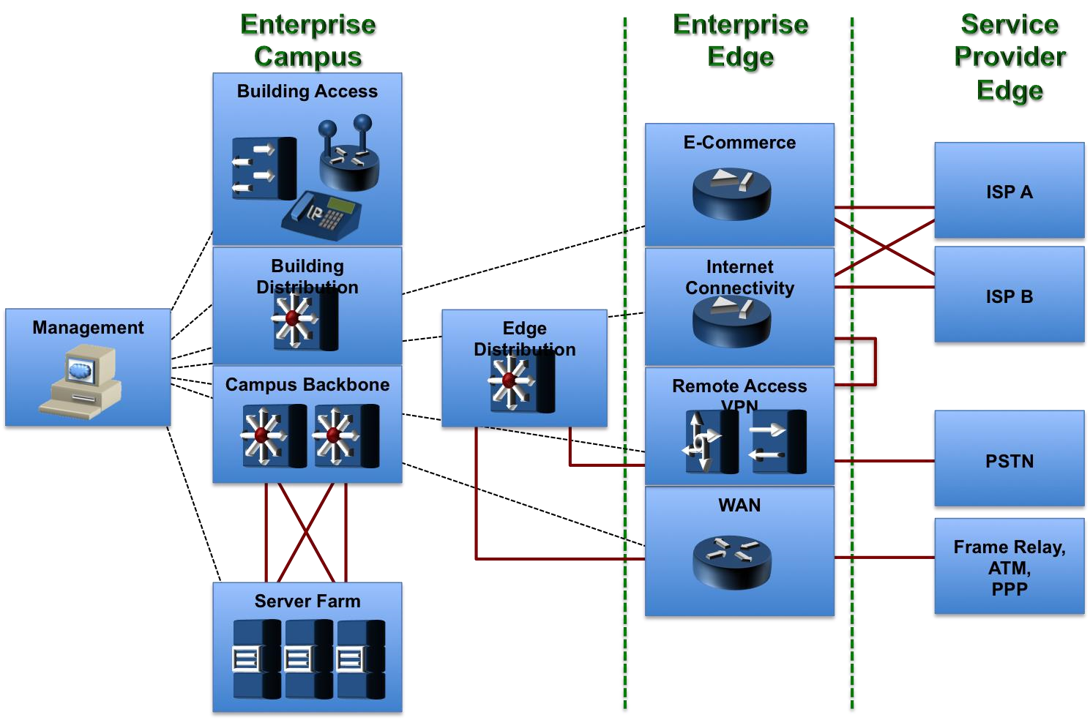

***Figure 1: Cisco enterprise composite network model***